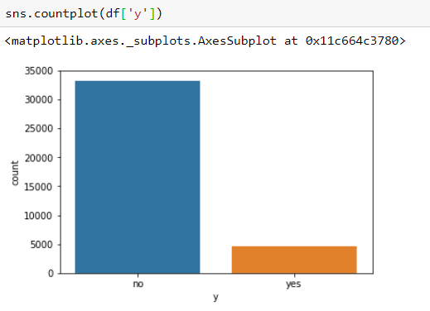

**Distribution of class variable**:  
First we will look into the class distribution to see if it is a balanced data or not.

We can see from the above plot that the dataset in imbalanced, where the number of negative class is close to 8 times the number of positive class.

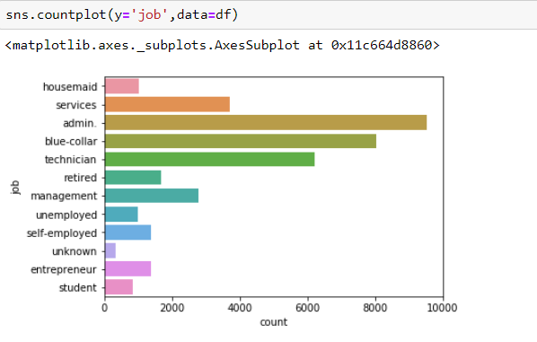

From the above plot, we can see that the customers who have a job of admin have the highest rate of subscribing a term deposit

**Marital:**This simply denotes the customer’s marital status.

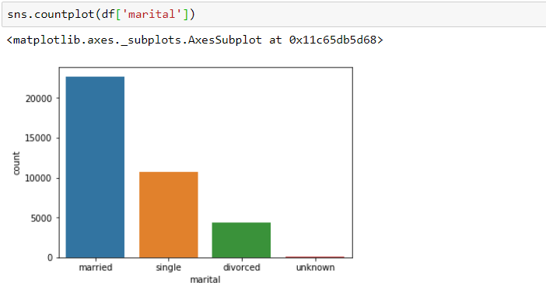Majority of the customers are married. Followed by Single, divorced and unknown.